**FTP Sampler**

**Installing FTP Protocol Support from JMeter Plugins**

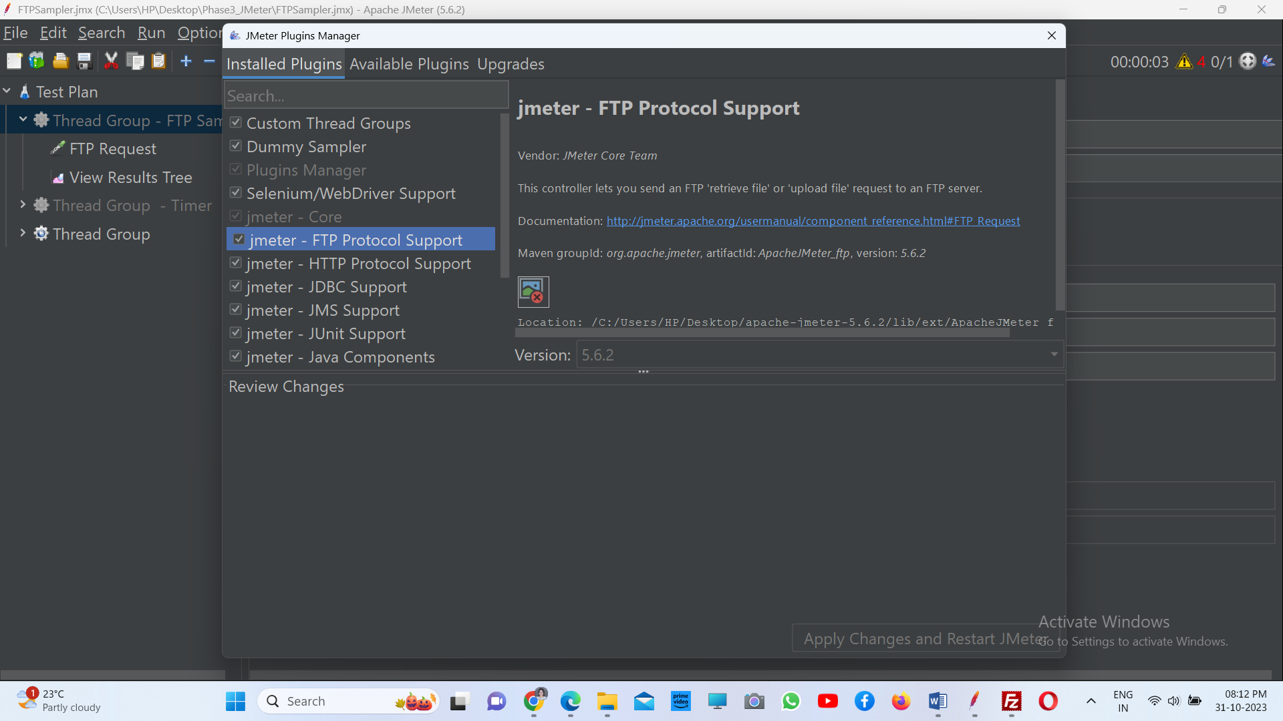

**Adding FTP Request Sampler**

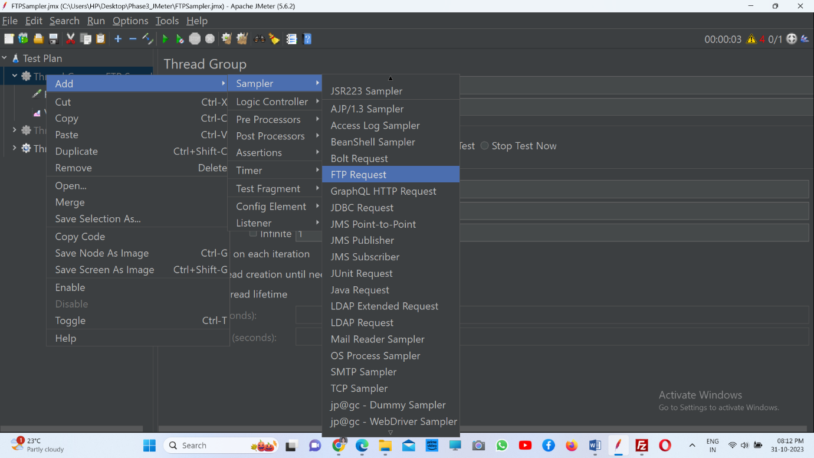

**Uploading a file into a FTP server**

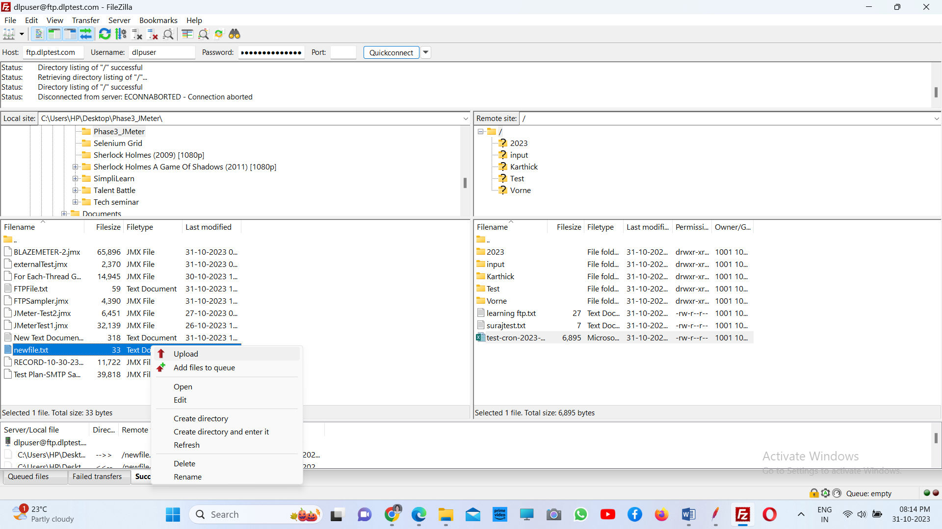

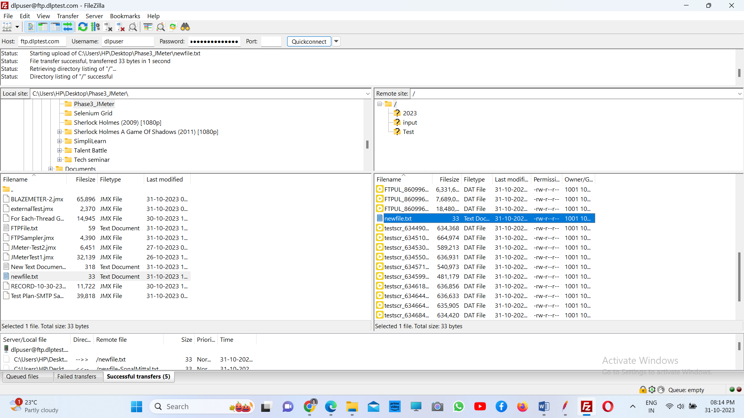

**Configuring FTP Request for downloading the file from server**

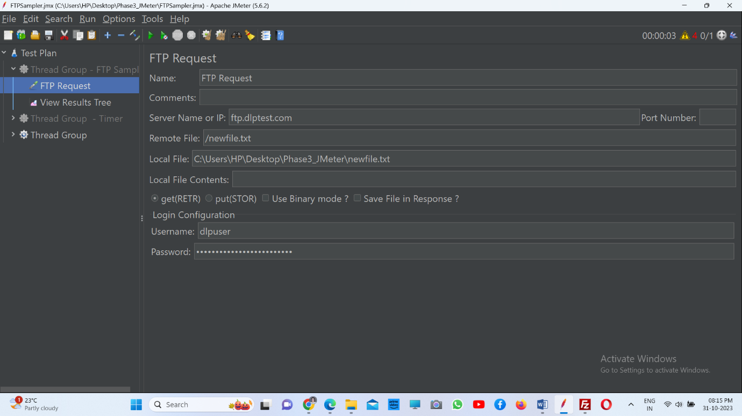

**Viewing Result**

